Tools -> sites and services ->

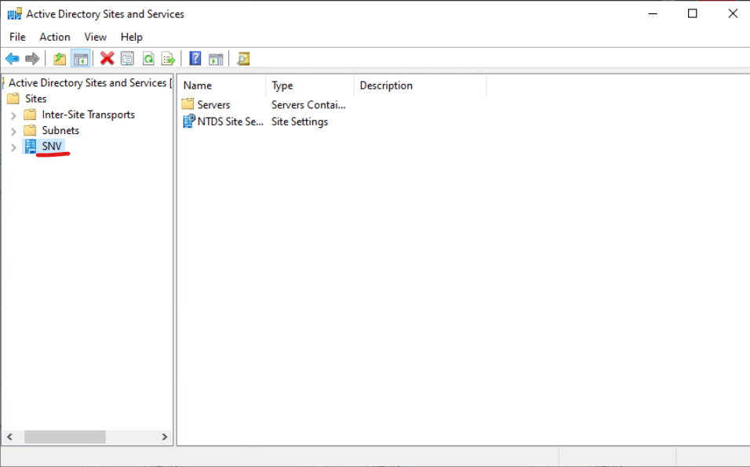

Toto premenovat

Poto to -> servers -> hl server -> RMB -> replicate

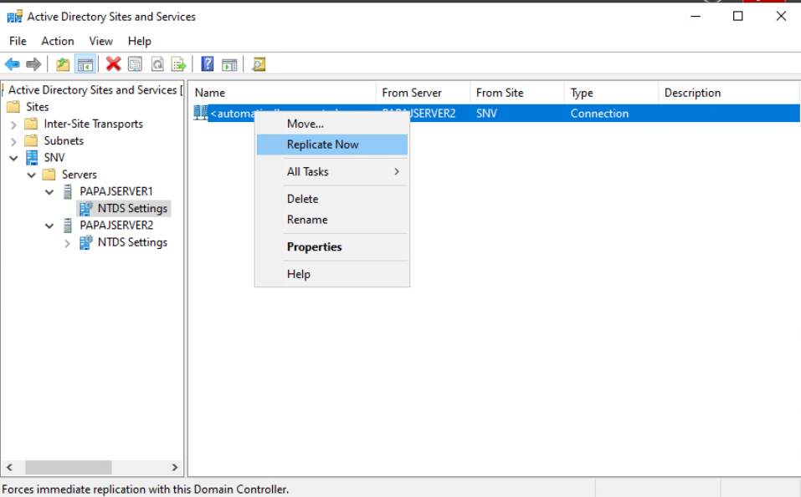

Nova linka

Sites -> RMB -> create a new site

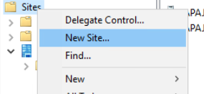

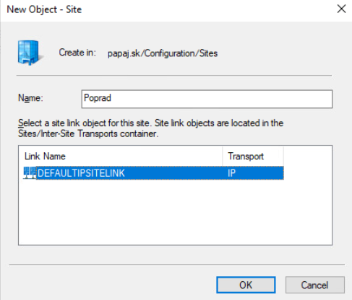

Prenos servera

LMB + hold on server premiestni to do toho druheho  
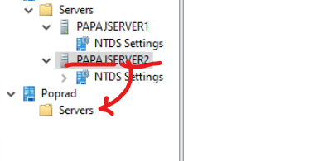

Yes  
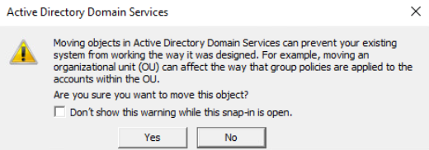

BOOM sikulka matej  
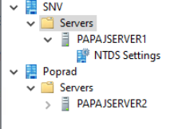

Tools -> group policy management

Forest -> domains -> papaj.sk -> group policy objects

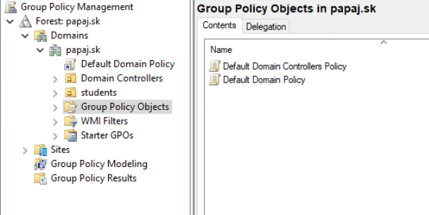

2x LMB default domain policy

A setting ale picovina vyskoci

Tak pojdeme

Server manager -> local server -> IE enhanced security configuration a tam vsetko off

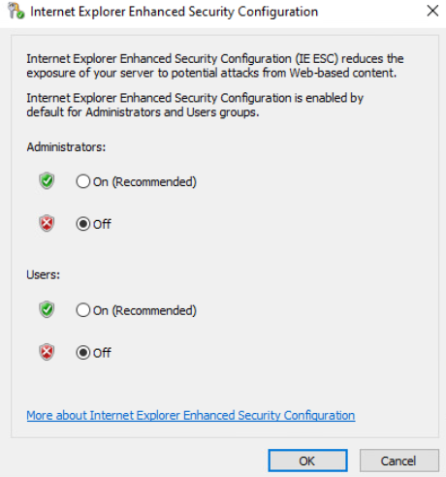

Nove group policy RMB na group policy objects

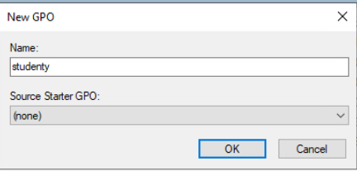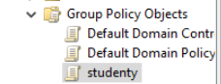

Wow a mam, si sikulka

Dalej prave na to a edit